

National University of Technology (NUTECH)

Name: Shiza Khizar

ID: F22605038

Department : Computer Science

PBL : 01

Instructor : Ma’am Saima

Course: NLP

NLP Project-Based Learning (PBL) Report
SentimentSense+: A Multi-Task Text Classification & Tagging System

1. Introduction
Natural Language Processing (NLP) is a major field of Artificial Intelligence that focuses on enabling machines to understand, analyze, and interpret human language. NLP techniques are widely applied in areas such as sentiment analysis, content moderation, topic categorization, and linguistic analysis of text.
The objective of this project is to design and deploy an interactive NLP system that allows users to input text and observe the results of different NLP tasks in real time through a user-friendly interface. The project is implemented as a web-based application, fulfilling the requirements of the NLP Project-Based Learning (PBL) challenge.

2. Selected NLP Category and Specific Task
Selected NLP Category
Text Classification & Tagging
Core Task
Sentiment Analysis
Additional Tasks (Extensions under the Same Category)
- Toxic Content Detection
- Topic Classification
- Part-of-Speech (POS) Tagging
The project primarily focuses on Sentiment Analysis as the core task, which involves classifying text into predefined sentiment categories. The additional tasks are implemented as extended demonstrations under the same NLP category to showcase the versatility of text classification and tagging techniques.

3. Data Used
Data Source
This project uses pretrained NLP models, which have already been trained on large, publicly available benchmark datasets.
- Sentiment Analysis: Models trained on datasets such as the Stanford Sentiment Treebank (SST-2) and IMDb movie reviews, containing tens of thousands of labeled samples.
- Toxic Content Detection: Models trained on large-scale toxicity datasets collected from online user comments.
- Topic Classification: Uses a zero-shot learning approach, enabling topic prediction without task-specific labeled datasets.
- Part-of-Speech Tagging: Uses annotated linguistic corpora integrated into the spaCy language model.
Dataset Size
The original training datasets used for these pretrained models consist of tens to hundreds of thousands of text samples, ensuring strong generalization and robustness.
Preprocessing
Text preprocessing is handled internally by the models and includes:
- Tokenization
- Lowercasing
- Padding and truncation
- Conversion of text into numerical embeddings
Since pretrained models are used, no manual dataset cleaning, splitting, or labeling was required.

4. Model Architecture and Training Process
Model Architecture
The system is based on transformer-based architectures, which use self-attention mechanisms to capture contextual relationships between words in a sentence. Transformers are highly effective for text classification and tagging tasks due to their ability to model long-range dependencies.
Models Used
Task | Model
Sentiment Analysis | Pretrained transformer pipeline
Toxic Content Detection | unitary/toxic-bert
Topic Classification | Zero-shot classification transformer
POS Tagging | spaCy en_core_web_sm
Training Process
In this project, the models were not trained from scratch. Instead, transfer learning was employed by directly using pretrained transformer models. The training had already been performed on large benchmark datasets, and the models were used for inference within the interactive system.

5. System Implementation
Interactive Interface
The system is implemented using Streamlit, a Python-based framework for building interactive web applications.
User Workflow
- The user enters text into the input field.
- The user selects an NLP task from the available options.
- The system loads the required model on demand.
- The model processes the input text.
- The result is displayed instantly on the interface.
Key Features
- Single unified interface
- Multiple NLP tasks under one category
- Real-time processing
- On-demand model loading for efficiency

6. Evaluation Metrics and System Performance
The pretrained models internally optimize standard evaluation metrics during their original training, including:
- Accuracy
- Precision
- Recall
- F1-score
During system testing, the models produced high-confidence predictions across a wide range of example inputs. The confidence scores provided by the models indicate reliable and consistent performance for all implemented tasks. The system successfully classified sentiment, detected toxic content, identified topics, and assigned correct part-of-speech tags during testing.

7. Challenges Encountered and Solutions
Challenge 1: Slow Model Loading
- Issue: Loading multiple large NLP models simultaneously caused long startup delays.
- Solution: Implemented on-demand model loading with caching to ensure smooth performance.
Challenge 2: Resource Constraints
- Issue: Large transformer models consumed significant memory.
- Solution: Used lightweight pretrained models and efficient caching mechanisms.
Challenge 3: Assignment Scope Interpretation
- Issue: Clarifying whether multiple tasks could be implemented.
- Solution: Ensured that all tasks remained under a single NLP category and clearly defined Sentiment Analysis as the core task.

8. Results and Demonstration
The final system successfully demonstrates:
- Sentiment Analysis (Positive/Negative classification)
- Toxic Content Detection
- Topic Classification
- Part-of-Speech Tagging
The system is fully interactive and suitable for live demonstration, meeting all functional and technical requirements of the assignment.
Sentiment Analysis:
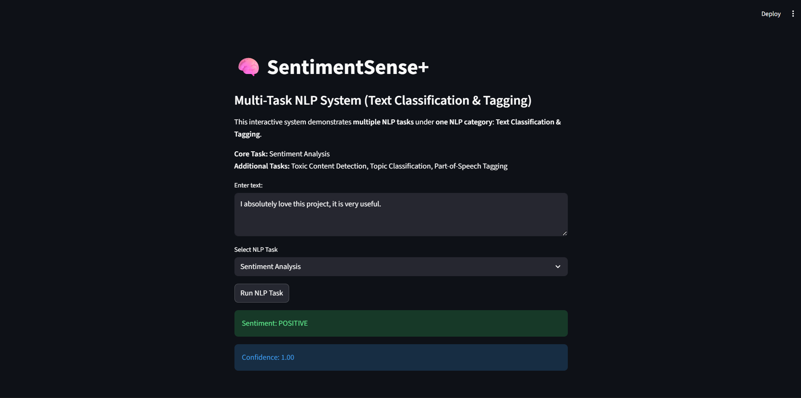
Toxic Content Detection:
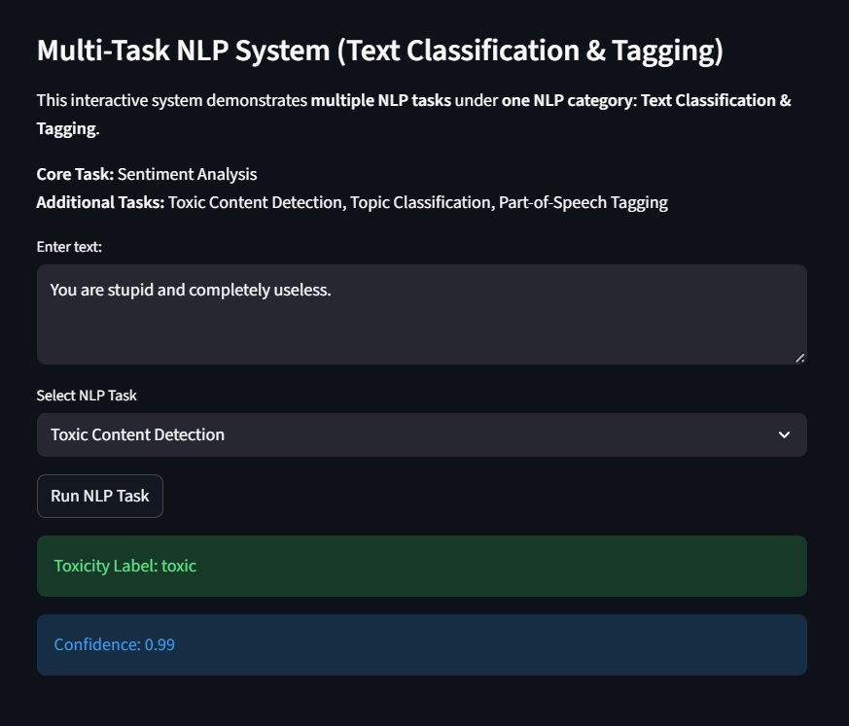
Topic Classification:
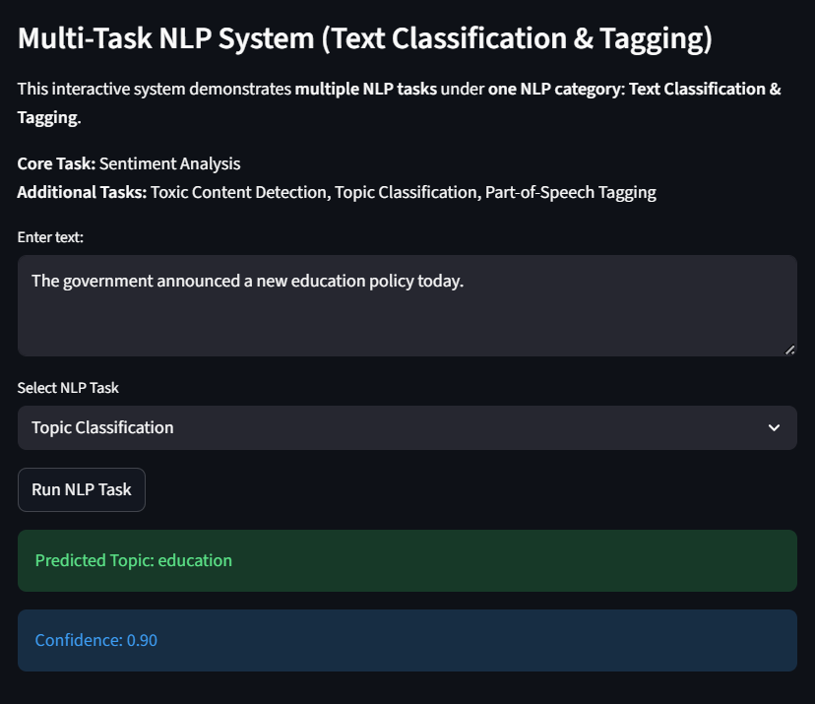
Part-of-Speech Tagging:
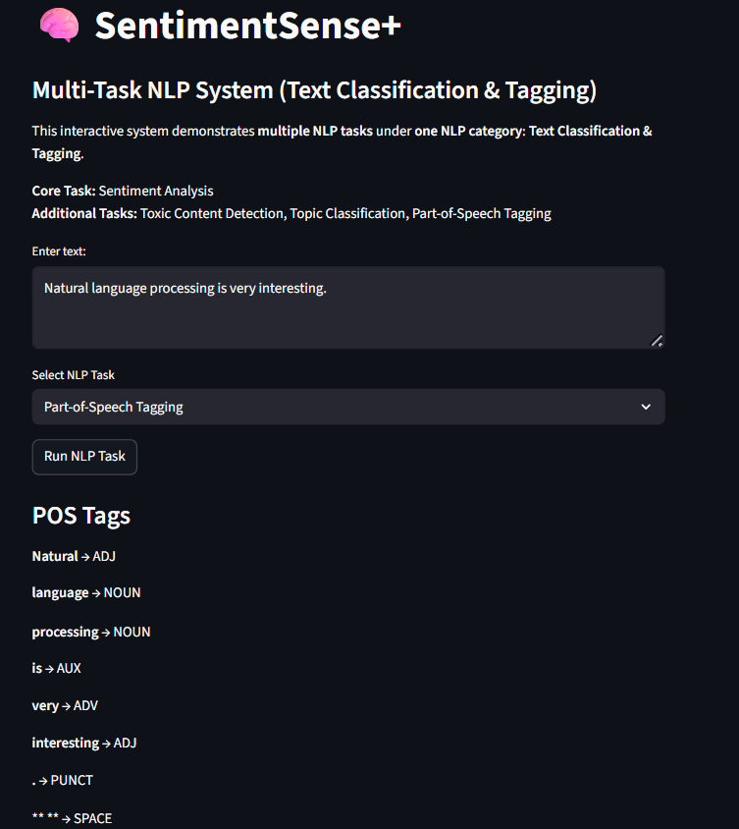
9. Conclusion and Future Work
This project successfully implements an interactive Text Classification & Tagging system using modern NLP techniques. By integrating multiple NLP tasks into a single interface, the system demonstrates the practical applicability of pretrained transformer models.
Future Enhancements
- Multilingual support
- Custom dataset training
- Advanced visualization of results
- Cloud deployment

10. GitHub Deployment
The complete project, including source code, model usage, and documentation, has been deployed to a public GitHub repository. All team members and the instructor have been added as collaborators in accordance with the submission requirements.

